|  |  |  |
| --- | --- | --- |
| **Attribute** | **Parameter value** |  |
| Product Catalogue | USB connector |  |
| Connector Type | Type-A |  |
| Standard | USB 2.0 |  |
| Male-Female | Female connector |  |
| Number of Contacts | 4 |  |
| Number of Ports | 1 |  |

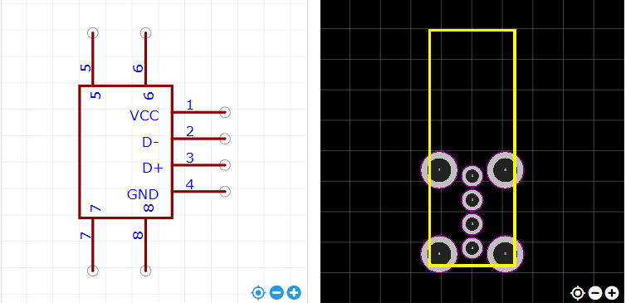

<https://item.szlcsc.com/26978.html>